CAPSTONE FLIGHT TEST

# GOAL:

Perform a flight test carrying the 1500-CAM prototype.

* Fly with additional weight
* Additional electrical load
* Use 1500-OEM to record flight video for post processing

# PREFLIGHT CHECKLIST

1. Verify Ethernet communication

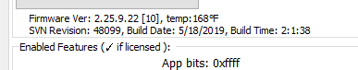

1. Verify video in main Panel+ window
2. Verify streaming statistics

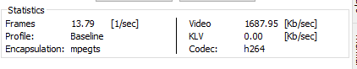

1. Verify microSD card is active

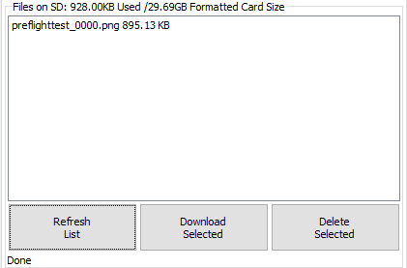

# FLIGHT PROCEDURE

1. Menu 🡪 Configure 🡪 KLV Setup…
   1. Simulate Data
   2. Display Decoded Value == MISB User Set
   3. VERIFY: UTC TIME == Current Date and Time
   4. Stop Simulation
   5. Tag Data Rate
      1. Check ID 2 box
      2. Set Frame Step = 1
      3. Send

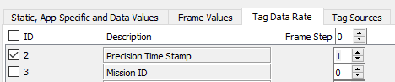

* 1. Close KLV Dialog

1. Verify KLV rate statistics

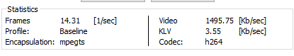

1. Record Tab: Single Frames (Snapshots)
   1. Set Filename (text only; no numbers)
   2. Start

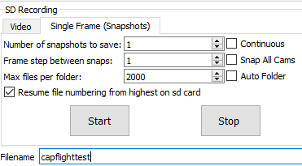

* 1. Refresh List
  2. VERIFY: new file

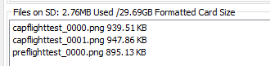

1. Record Tab: Video
   1. Start
   2. Refresh List
   3. VERIFY: new file is getting created

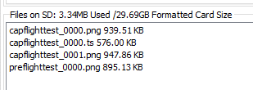

# 1500-SETUP

|  |
| --- |
|  |
|  |
|  |
|  |
|  |
|  |
|  |
|  |
|  |